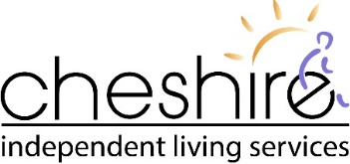

**2023-2024 HEALTH & SAFETY POLICY STATEMENT & GOALS**

**HEALTH & SAFETY POLICY STATEMENT**

The health and safety of our employees is important. Our policy is to strive for the highest possible level of safety and to comply with all applicable laws. We are committed to the prevention of occupational illness and injury. We believe that prevention is key to reducing the human and economic costs associated with workplace injuries, accidents and illness. We do this with the help and cooperation of our employees and consumers. Everyone must be conscientious about work safety including proper work methods, reporting potential hazards and decreasing known hazards.

Cheshire will make every reasonable and practical effort to provide and maintain a safe and healthy occupational environment. It must be remembered that most work areas are consumers’ private homes and as such warrant respect for individual needs, styles, cultures, likes and dislikes.

Cheshire employees, consumers, leaders and board members are responsible for complying with all legislative and organizational policies, procedures and practices related to health and safety. Moreover, they are responsible for actively promoting, identifying and reporting the need for change or updating current information and practices.

While prevention is our goal, Cheshire is also committed to the active rehabilitation of workers who are injured. We do this by providing early and safe return to work duties where necessary and by working cooperatively with the injured worker and their health care providers to develop return to work strategies that facilitate their recovery.

Cheshire continues to work towards the elimination of workplace injuries. Working with our Joint Occupational Health & Safety Committees and building on the foundation of a comprehensive Health & Safety program, our goals this year will focus on the following areas:

* **Injury Reduction**

Cheshire will promote the reduction of workplace injuries by actively engaging staff, consumers, stakeholders, visitors, Joint Occupational Health and Safety representatives and external persons where necessary in identifying hazards and implementing prevention initiatives that enhance the organizations health and safety management system.

* **Workplace Harassment and Violence**

Cheshire encourages the reporting of all workplace harassment and violence circumstances within the organization. Cheshire is committed to providing a safe environment for all employees. Cheshire will ensure that harassment and violence policies and procedures are up to date, and ensure that all employees are adequately trained.

* **Hazard Identification and Awareness**

Cheshire promotes the reporting of all workplace hazards and will continue to establish hazard campaigns with a strong focus on Occupational Illness. Cheshire will network with like agencies to find additional training programs that will benefit our staff, and to help to mitigate risk while ensuring a safe workplace for all.

* **Personal Safety Awareness and Training**

Cheshire identifies that in our communities there is a strong need to ensure that personal safety and awareness while working alone. Cheshire is committed to maintaining best practice with protocols and safety measures and will continue to network with other agencies to ensure we are providing the best personal safety protocols for our employees

*Thank you for being our partner in Health & Safety.*

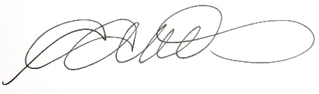

Angela McMillan, Executive Director